S.A.L.S.A.

San Antonio League of Self-Advocates
S.A.L.S.A. is a 501(c)(3) not-for-profit organization.

Dear Friend of SALSA,

We have chosen Birdies for Charity as our fundraiser this year because other programs we used in the past charge several hundred dollars to participate. With Birdies, we will receive 100% of every penny we raise and even earn an additional 7% bonus if we reach the $1000 goal. Valero Texas Open and Birdies for Charity pay all costs to run the program.

We would also be very grateful if you would forward this letter to your friends, family, and co-workers to pledge as well. You will be helping us spread the word.

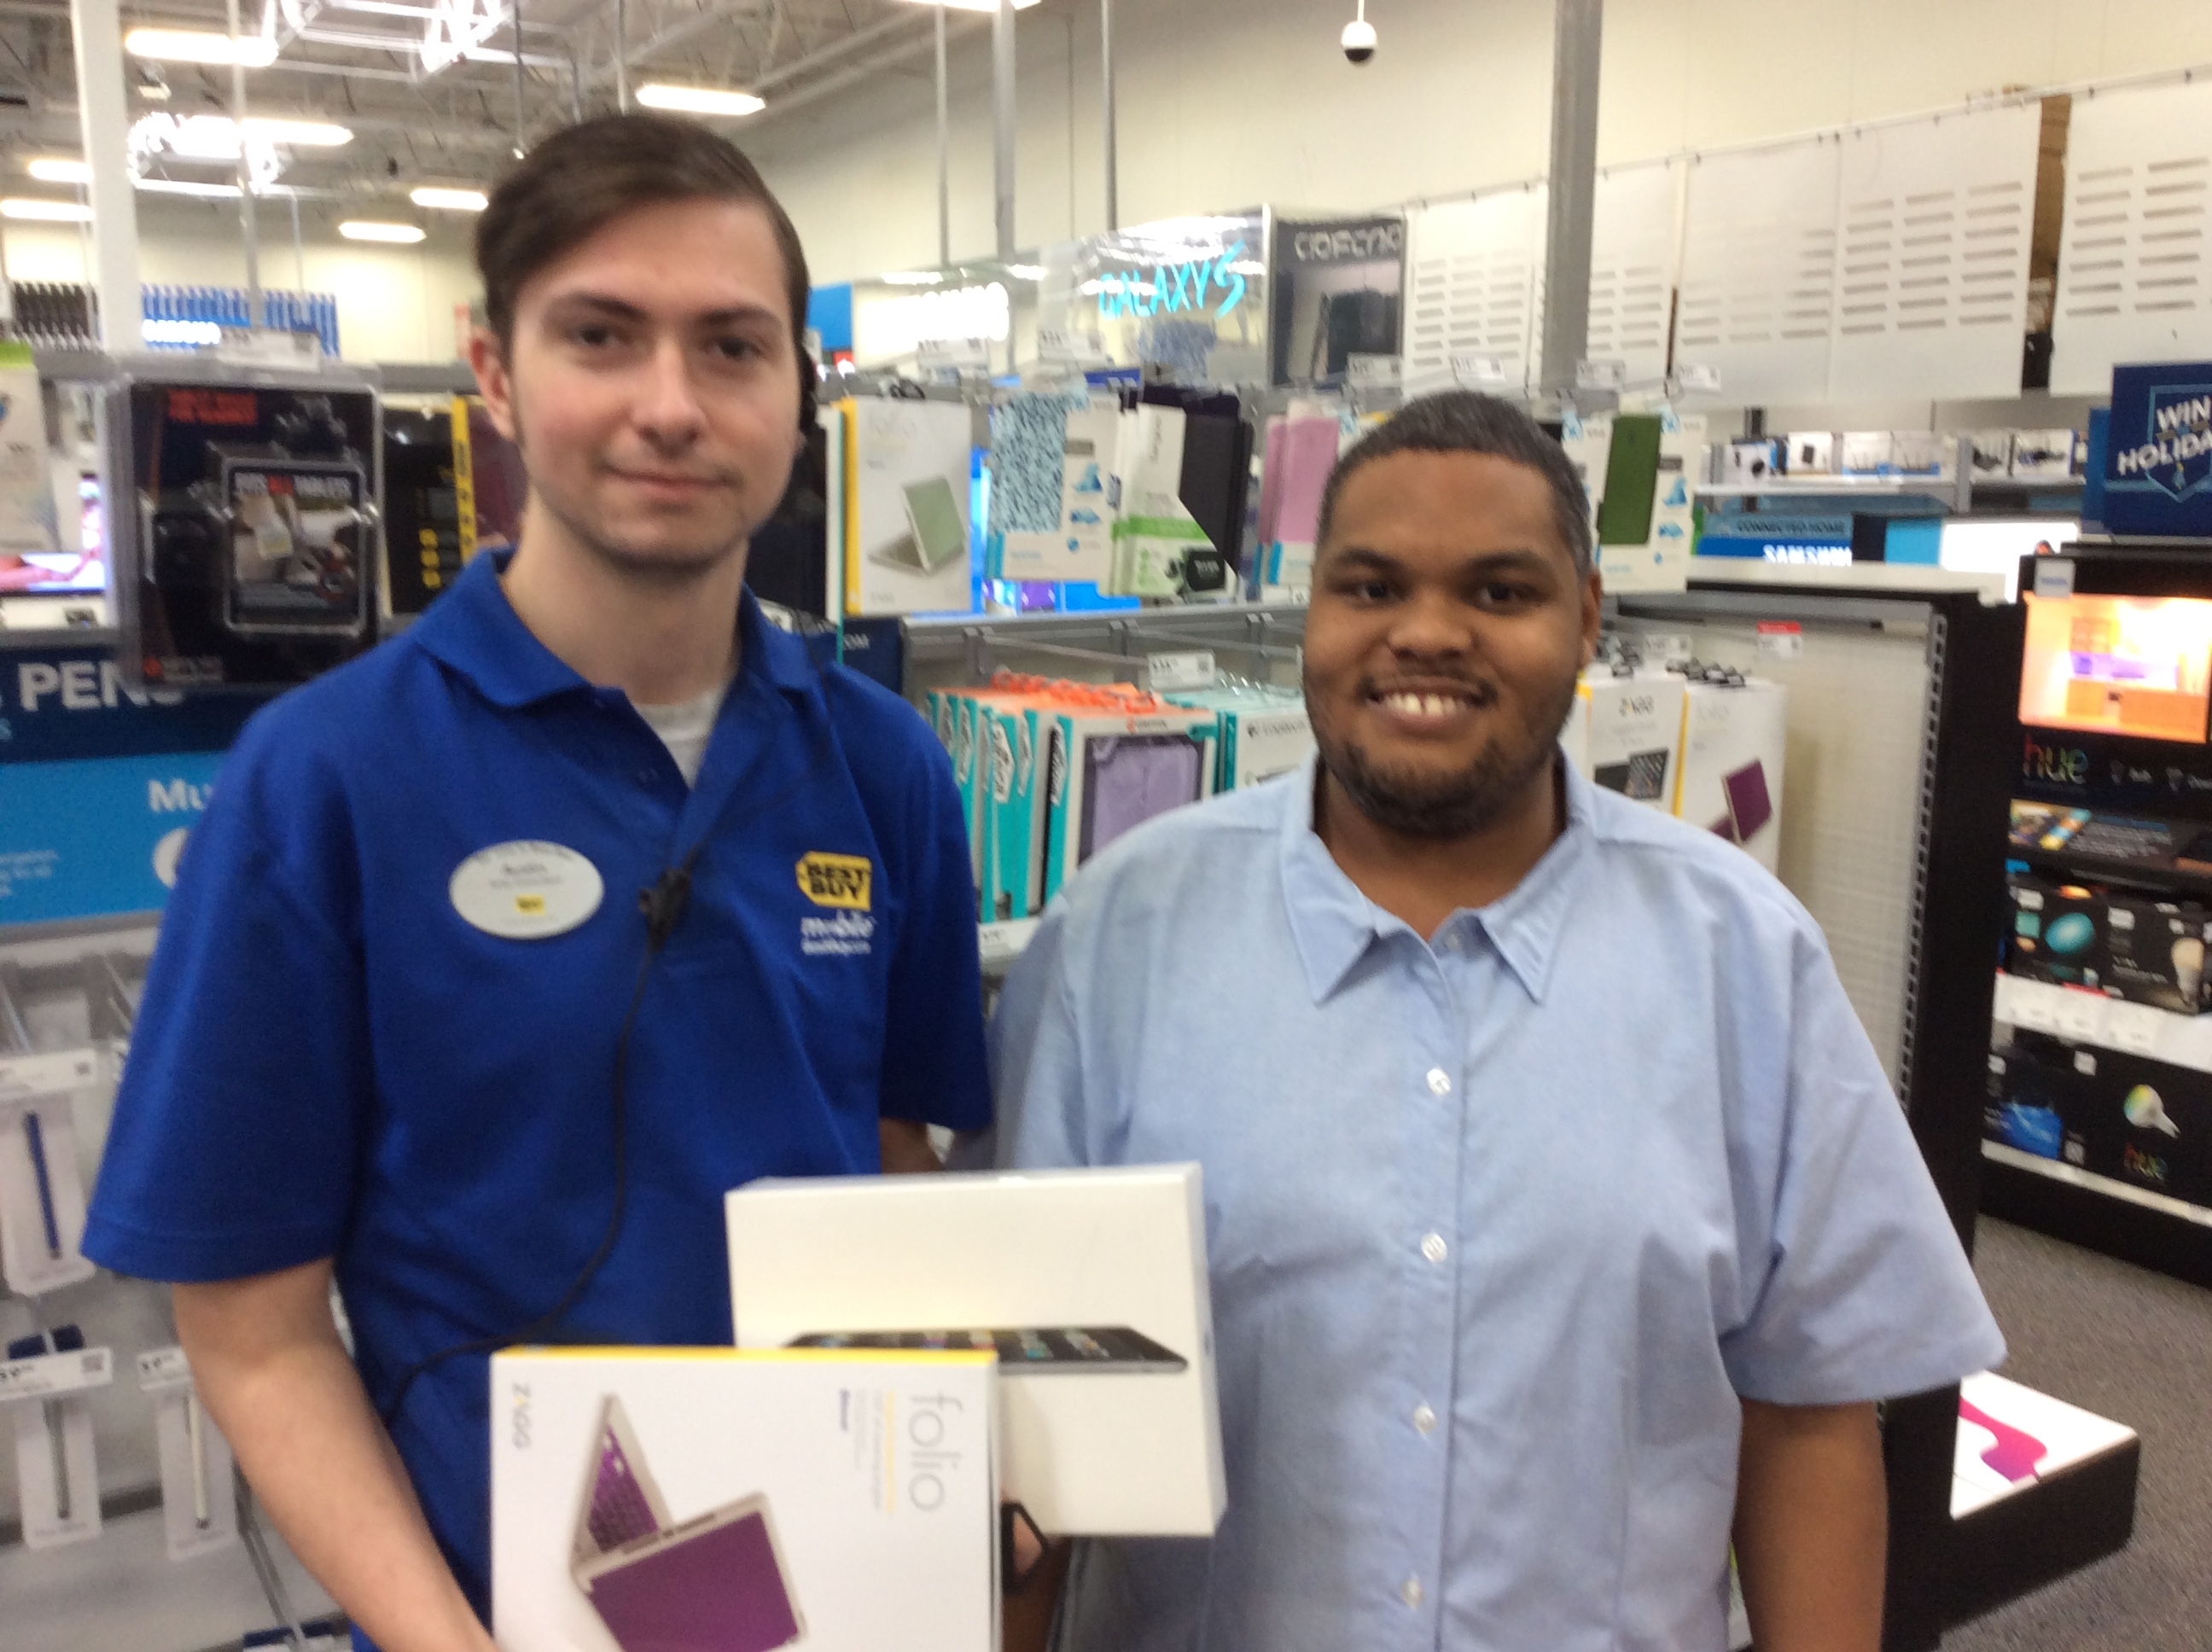
How YOU will make an impact…
Our past supporters will remember helping SALSA president, Kennis Price (at the right in the photo), raise money to buy the iPad and text-to-speech software that launched him as our favorite speaker and SALSA board member.

And you have provided over two hundred scholarships since 2002 for travel to the annual Texas Advocates (state) conference, supporting members who otherwise would not have been able to attend this empowering and life-changing weekend. This year we hope to give at least twelve scholarships, as provided by this fund drive. Please help as much as you can.
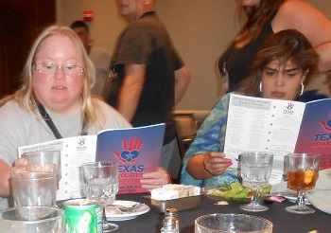

Thank you in advance for your support!
Most sincerely,
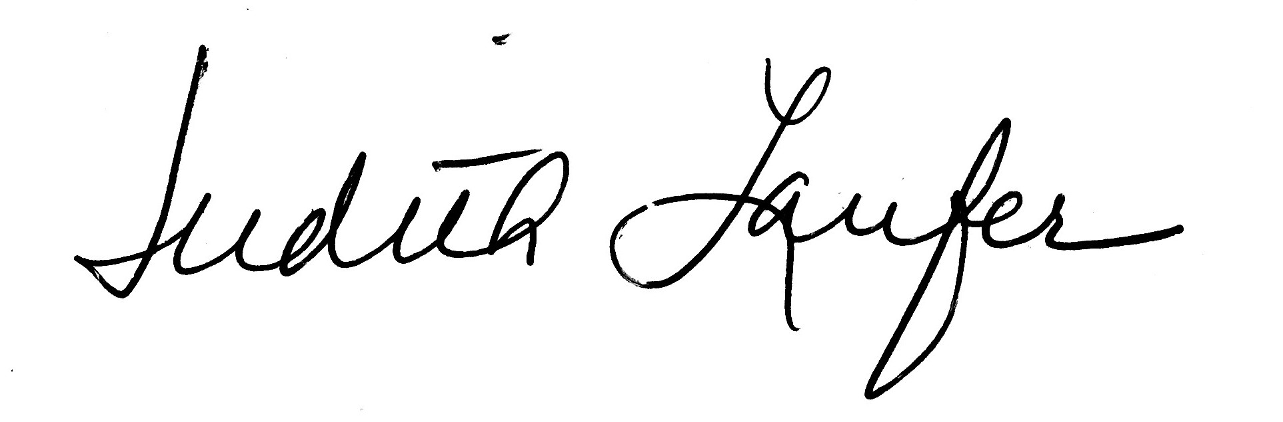
Judith Laufer, Advisor

